Name: Nethra JB
Reg No: 192524272

CSA5107- CRYPTOGRAPHY AND NETWORK SECURITY
LAB EXPERIMENTS

EXPERIMENT 4
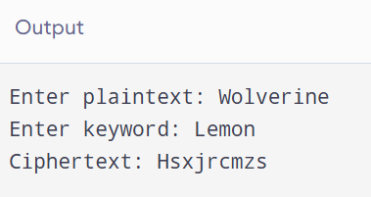
EXPERIMENT 5
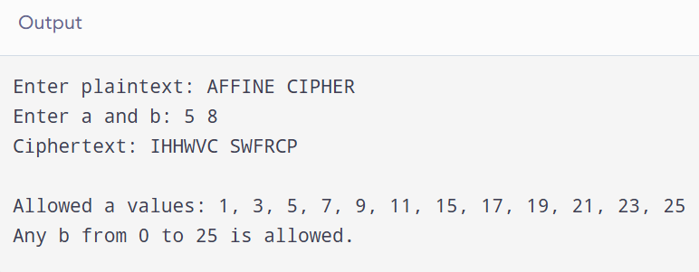

EXPERIMENT 6
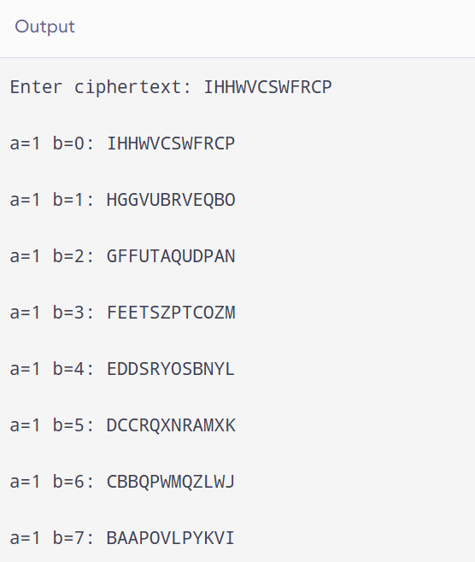

EXPERIMENT 8
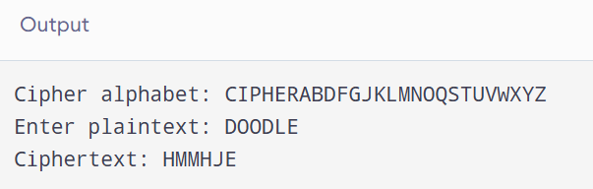

EXPERIMENT 9
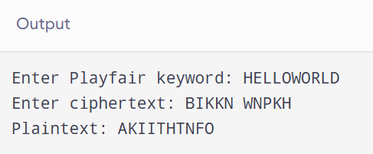

EXPERIMENT 10
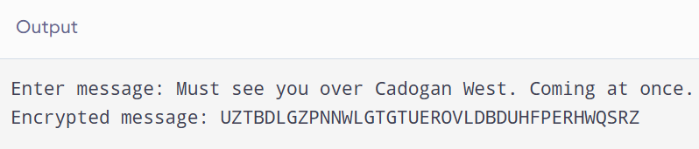

EXPERIMENT 11
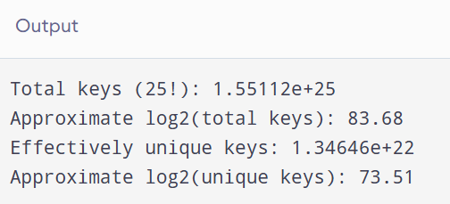

EXPERIMENT 12
a.
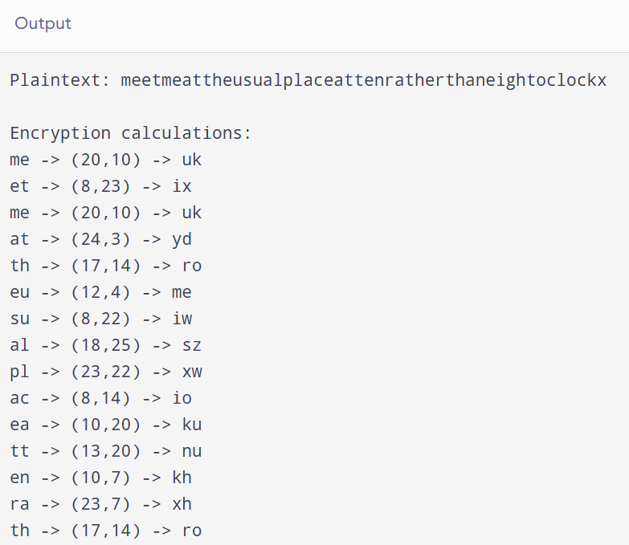

b.
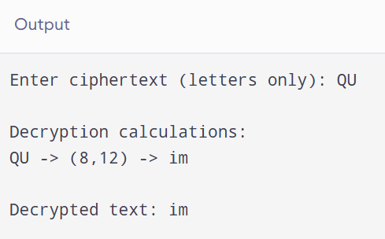

EXPERIMENT 13
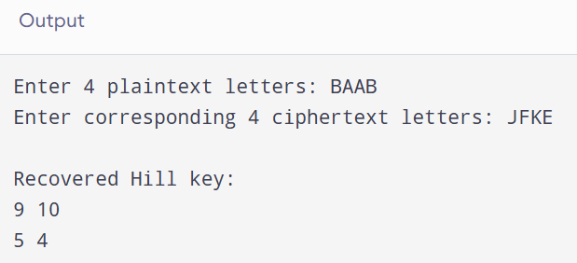

EXPERIMENT 14
a.
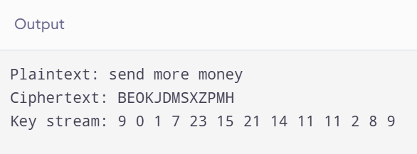

b.
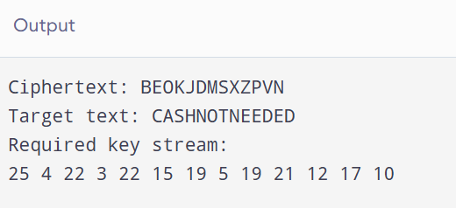

EXPERIMENT 15
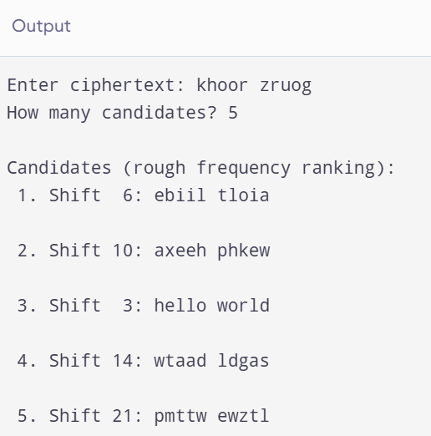

16.
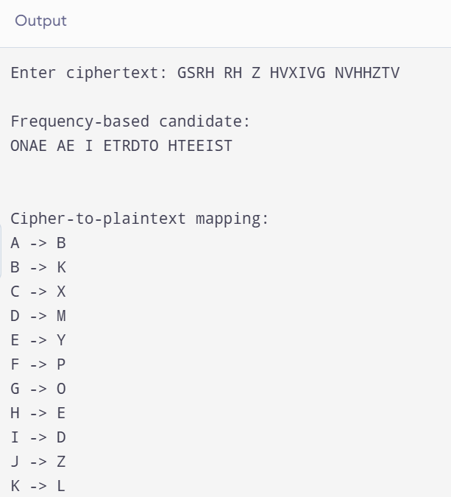
EXPERIMENT 17
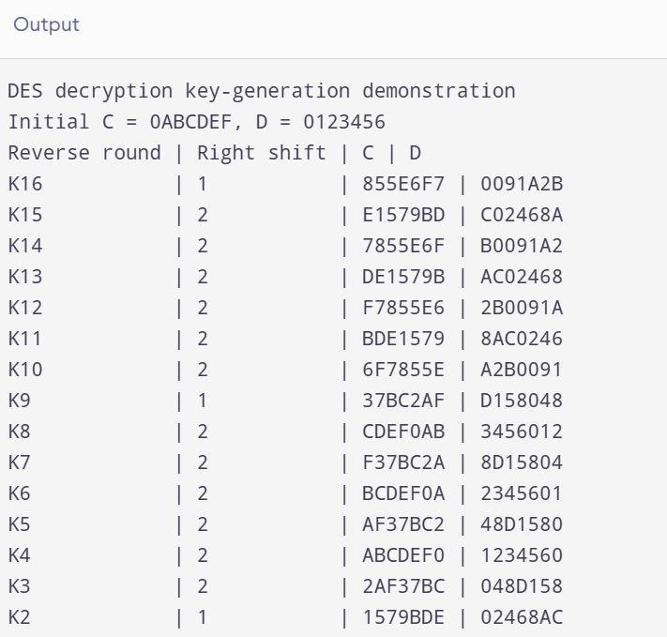
EXPERIMENT 18
